TABLE OF CONTENTS

1.Introduction…………………………………………………………………………………………… 3
1.1 Scope………………………………………………………………………………………... 3
1.2 Related Documents………………………………………………………………………..... 3
1.3 External Requirements……………………………………………………………………… 3
1.4 Internal Requirements………………………………………………………………………. 3
1.5 Design Issue………………………………………………………………………………… 3
2.Internal Design………………………………………………………………………………………... 4
2.1 Data Flows………………………………………………………………………………….. 5
3.Unit Test Strategy…………………………………………………………………………………….. 7
4.Additional Information……………………………………………………………………………….. 8
5.Reference……………………………………………………………………………………………... 9
6.Acronyms……………………………………………………………………………………………...10

Introduction
This Software will define the detail of animal’s life cycle and food chain according to the image of Saskatchewan Wildlife Federation. In terms of the customer’s requirements, this project will help students to study that the life cycle of animals, which live in a certain natural environment in Saskatchewan. And then the software will simulate the model of animal’s life cycle. In the software, those animals will be placed in a virtual place, and looking for the food to decide they will live or die.

Scope
The software will be coded by Java. A group is asked to design a simulation program that make student to add or delete a bunch of different animals in a simulated place to see what happens between various animals. From the wildlife image we can see the life circle but this is not complete. Therefore, we need to make sure we can add more animals at any time in the software.

Related Documents
See Internal Design Section

External Requirements
- The user can define which animals will in the life cycle, and they can add or delete the animals which they want or do not want

Internal Requirements
- Use Jave
- Use inheritance
- Work in a group
- Work with Github

Design issues
1) Mouse and BlueJay (Multiple Inheritance)

Internal Design

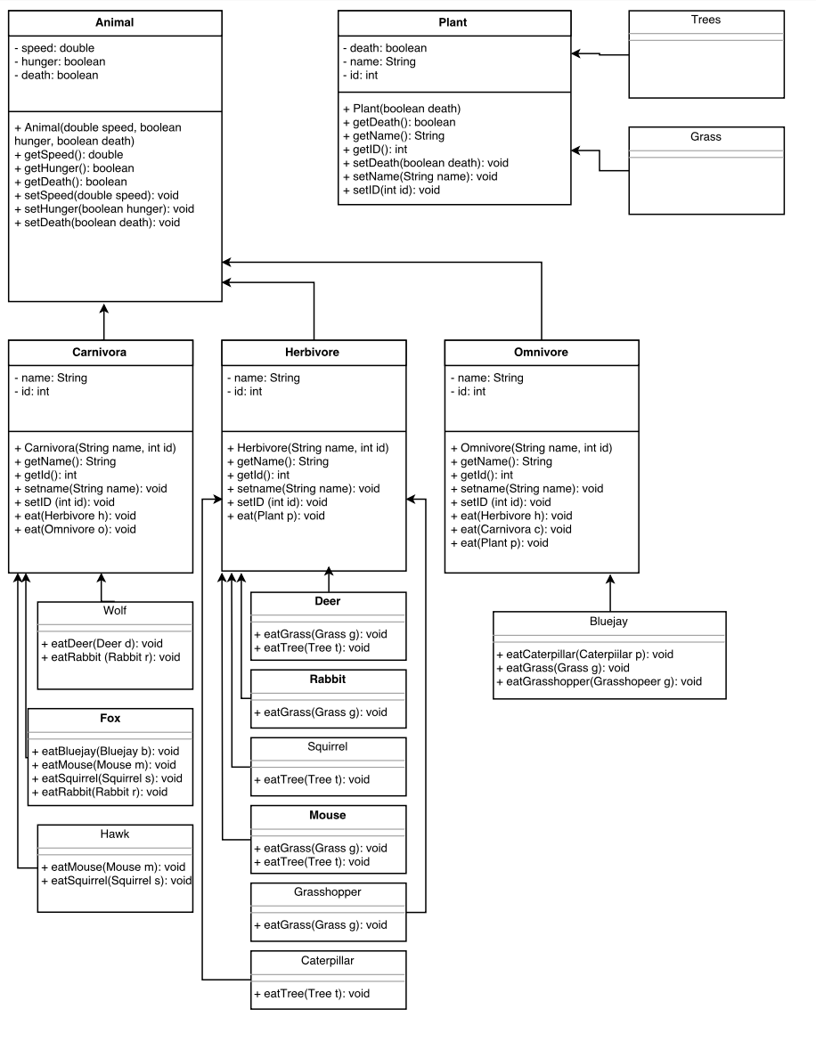

Data Flows

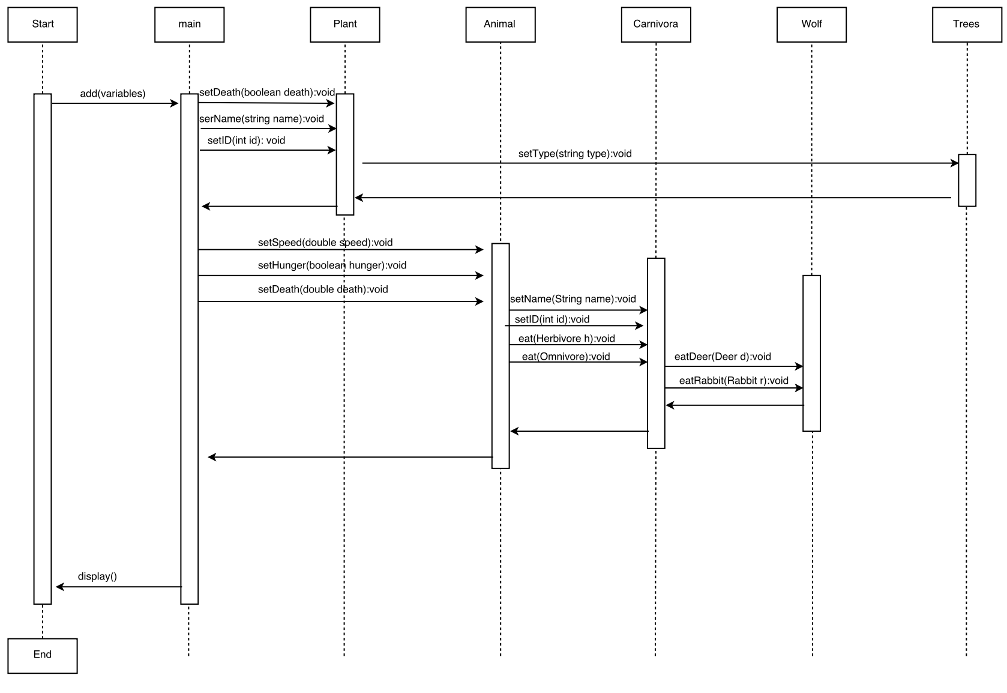

Unit Test Strategy
Please refer to the PPP section in [8] for a full unit test strategy.

Additional Information

References

Acronyms

